MTF Research Summary
John N. Rogers, III, Ryan Bearss, Jackie Guevara, and Evan Rogers
Michigan State University
January 2026

Research background: Since initiating the FIFA World Cup 2026 research program in 2022, our work primarily focused on the establishment of sod on plastic (SOP), including both stabilized and non-stabilized systems. In 2025, this body of work was largely completed, and emphasis transitioned to post-installation management.

Study #3: A programmatic approach to growth regulation of Kentucky bluegrass sod maintained of the shallow-profile system

The objective of this experiment was to identify a trinexapac-ethyl rate that can be applied at fixed intervals to maximize growth suppression while maintaining acceptable turf recovery. The experiment was conducted from spring 2025 through spring 2026. Big-roll Kentucky bluegrass (Poa pratensis L.) sod was harvested from Green Valley Sod Co. (Littleton, CO) and installed over the shallow-profile system at the Hancock Turfgrass Research Center. Whole plots were treated with trinexapac-ethyl at rates of 0.0, 0.1, 0.2, 0.4, 0.8, or 1.6 fl oz TNex M⁻¹ applied at 7-d intervals for an 8-wk period. Half of each plot was subjected to simulated traffic events during the first four weeks of the experiment. The trafficked halves were subsequently evaluated for growth and recovery during the remaining four weeks of the first experimental run. Plots were mown 3x weekly with clippings removed and subjected to chlorophyll and yield assays.

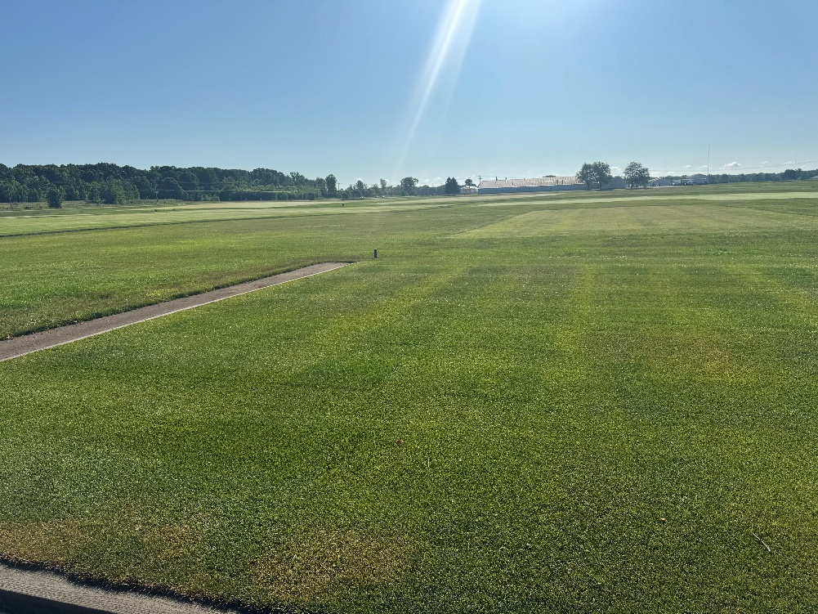
Figure 3. PGR dose-response trial, 6 weeks after initiation, prior to clipping collection (East Lansing, MI-2025).

Key findings:
- Predictable growth suppression was consistently achieved after four sequential PGR applications (regardless of rate).
- Peak predictability of suppression was achieved 5 weeks after the initial PGR application, where 0.127 fl oz TNex M⁻¹ effectively suppressed growth by 50%.
- All rates < 0.4 fl oz/M maintained > 85% turfgrass cover and achieved recovery of > 90% by the end of the first experimental run.
- Higher rates of PGR applied weekly resulted in significant increases in green color and chlorophyll content, however; at these rates the turf cannot recover.
- From these findings, we suggest groundskeepers apply TNex weekly at rates between 0.1-0.150 fl oz M⁻¹.

